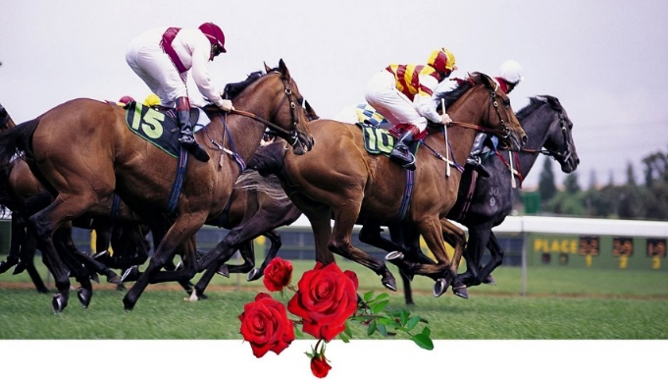
NIGHT AT THE RACES

May 2 • 5 PM – 9 PM

The Iron Mule

RACE BETTING | BEST HAT & DAPPER DAN CONTEST | RAFFLES | DINNER BUFFET

Event Sponsor
 | Gold Standard  $2,500 | Triple Crown  $1,000 | Kentucky Derby  $750 | Winners Circle  $500 | Mint Julep  $250
Logo on website | X | X | X | X | X
Large logo on posters/signage | X | X
Medium logo on posters/signage |  |  | X | X
Small logo on posters/signage |  |  |  |  | X
Recognition on social media | X | X
Full-page, back of program ad | X
Full-page ad in program |  | X
Half-page ad in program |  |  | X | X
“Presenting Sponsor” designation | X
Recognition in e-newsletter/press release | X | X | X
Option to provide branded promo materials | X | X | X | X | X
Event tickets | 10 | 6 | 4 | 2 | 2

Non-derby Race Sponsor $150

Buy a Horse $25 Program Book Advertisement Tickets

Horses’ and owners’ names will be listed Full-Page (bw/color) $150/$200 $50 each

in program & announced during race. Half-Page (bw/color) $90/$140 $400 Reserved Table

If your horse wins, you receive $75! Quarter-Page (bw/color) $50/$100 for 8.

Name: ______________________________________ Phone: ________________________ Email: ________________________________________
Address: _____________________________________________________________________________________________________________________________
Person/business/organization to be listed & announced for horse or sponsorship: _________________________________________
Name(s) of Horse(s): _____________________________________________________________________________________________________________
Ad: ____full page (5”x8”) ____1/2 page (5”x4”) ____1/4 page (5” x 2”)
____will send ad copy via email to ilong@eastonanc.org ____create ad for me
Sponsor level: ____Gold Standard ____Triple Crown ____Derby ____Winners’ Circle ____Mint Julep ____Race ____Game
Tickets ____ (specify quantity being purchased) Total amount enclosed $

Return this form with check payable to The Neighborhood Center to: Isla Long, Easton Area Neighborhood Centers, 902
Philadelphia Rd., Easton, PA 18042. Or use PayPal: http://www.eastonareaneighborhoodcenter.org/natr

