Support The Neighborhood Center

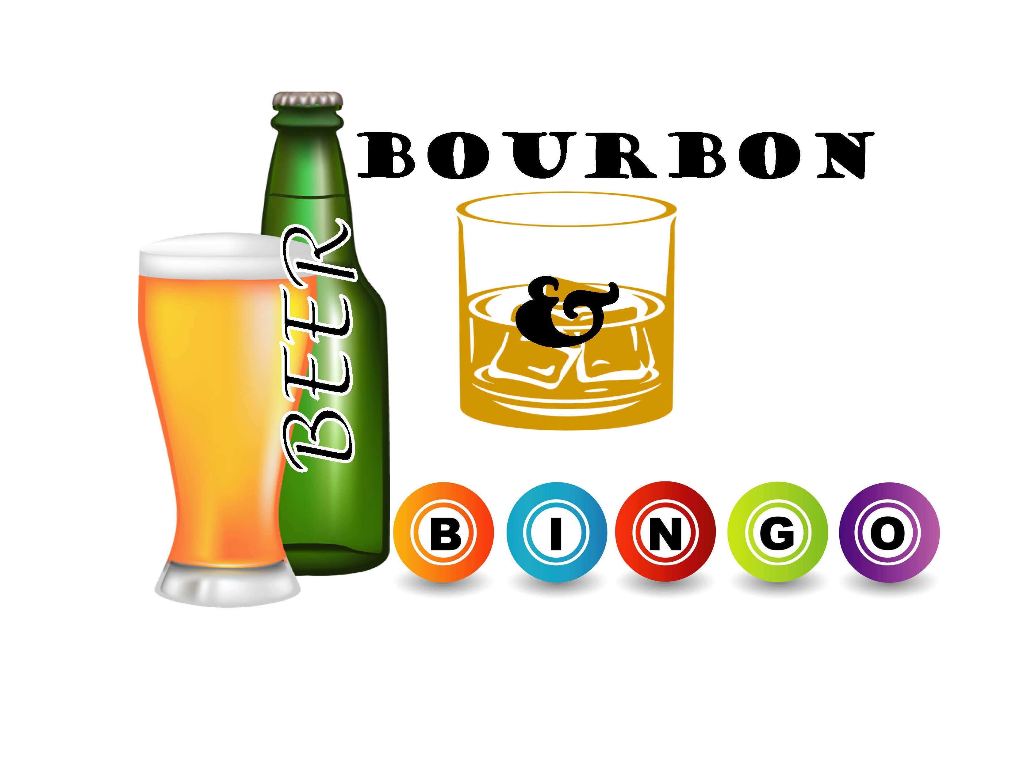 

**Program Book Advertisement**

Full-Page: $150 ($200 Color)

Half-Page: $100 ($150 color)

Quarter-Page: $75 ($125 color)

Name: Phone:

Email:

Address:

Ad: 🞎full page (8”x5”) 🞎1/2 page (4”x5”) 🞎1/4 page (2” x 5”) 🞎 Color 🞎 B&W

🞎 will send ad copy via email to [ilong@eastonanc.org](mailto:ilong@eastonanc.org) 🞎 create ad for me

TOTAL ENCLOSED:

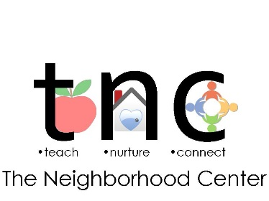

902 Philadelphia Road, Easton, PA 18042

[www.eastonareneighborhoodcenter.org](http://www.eastonareneighborhoodcenter.org)

(610) 253-4253