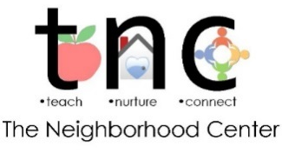
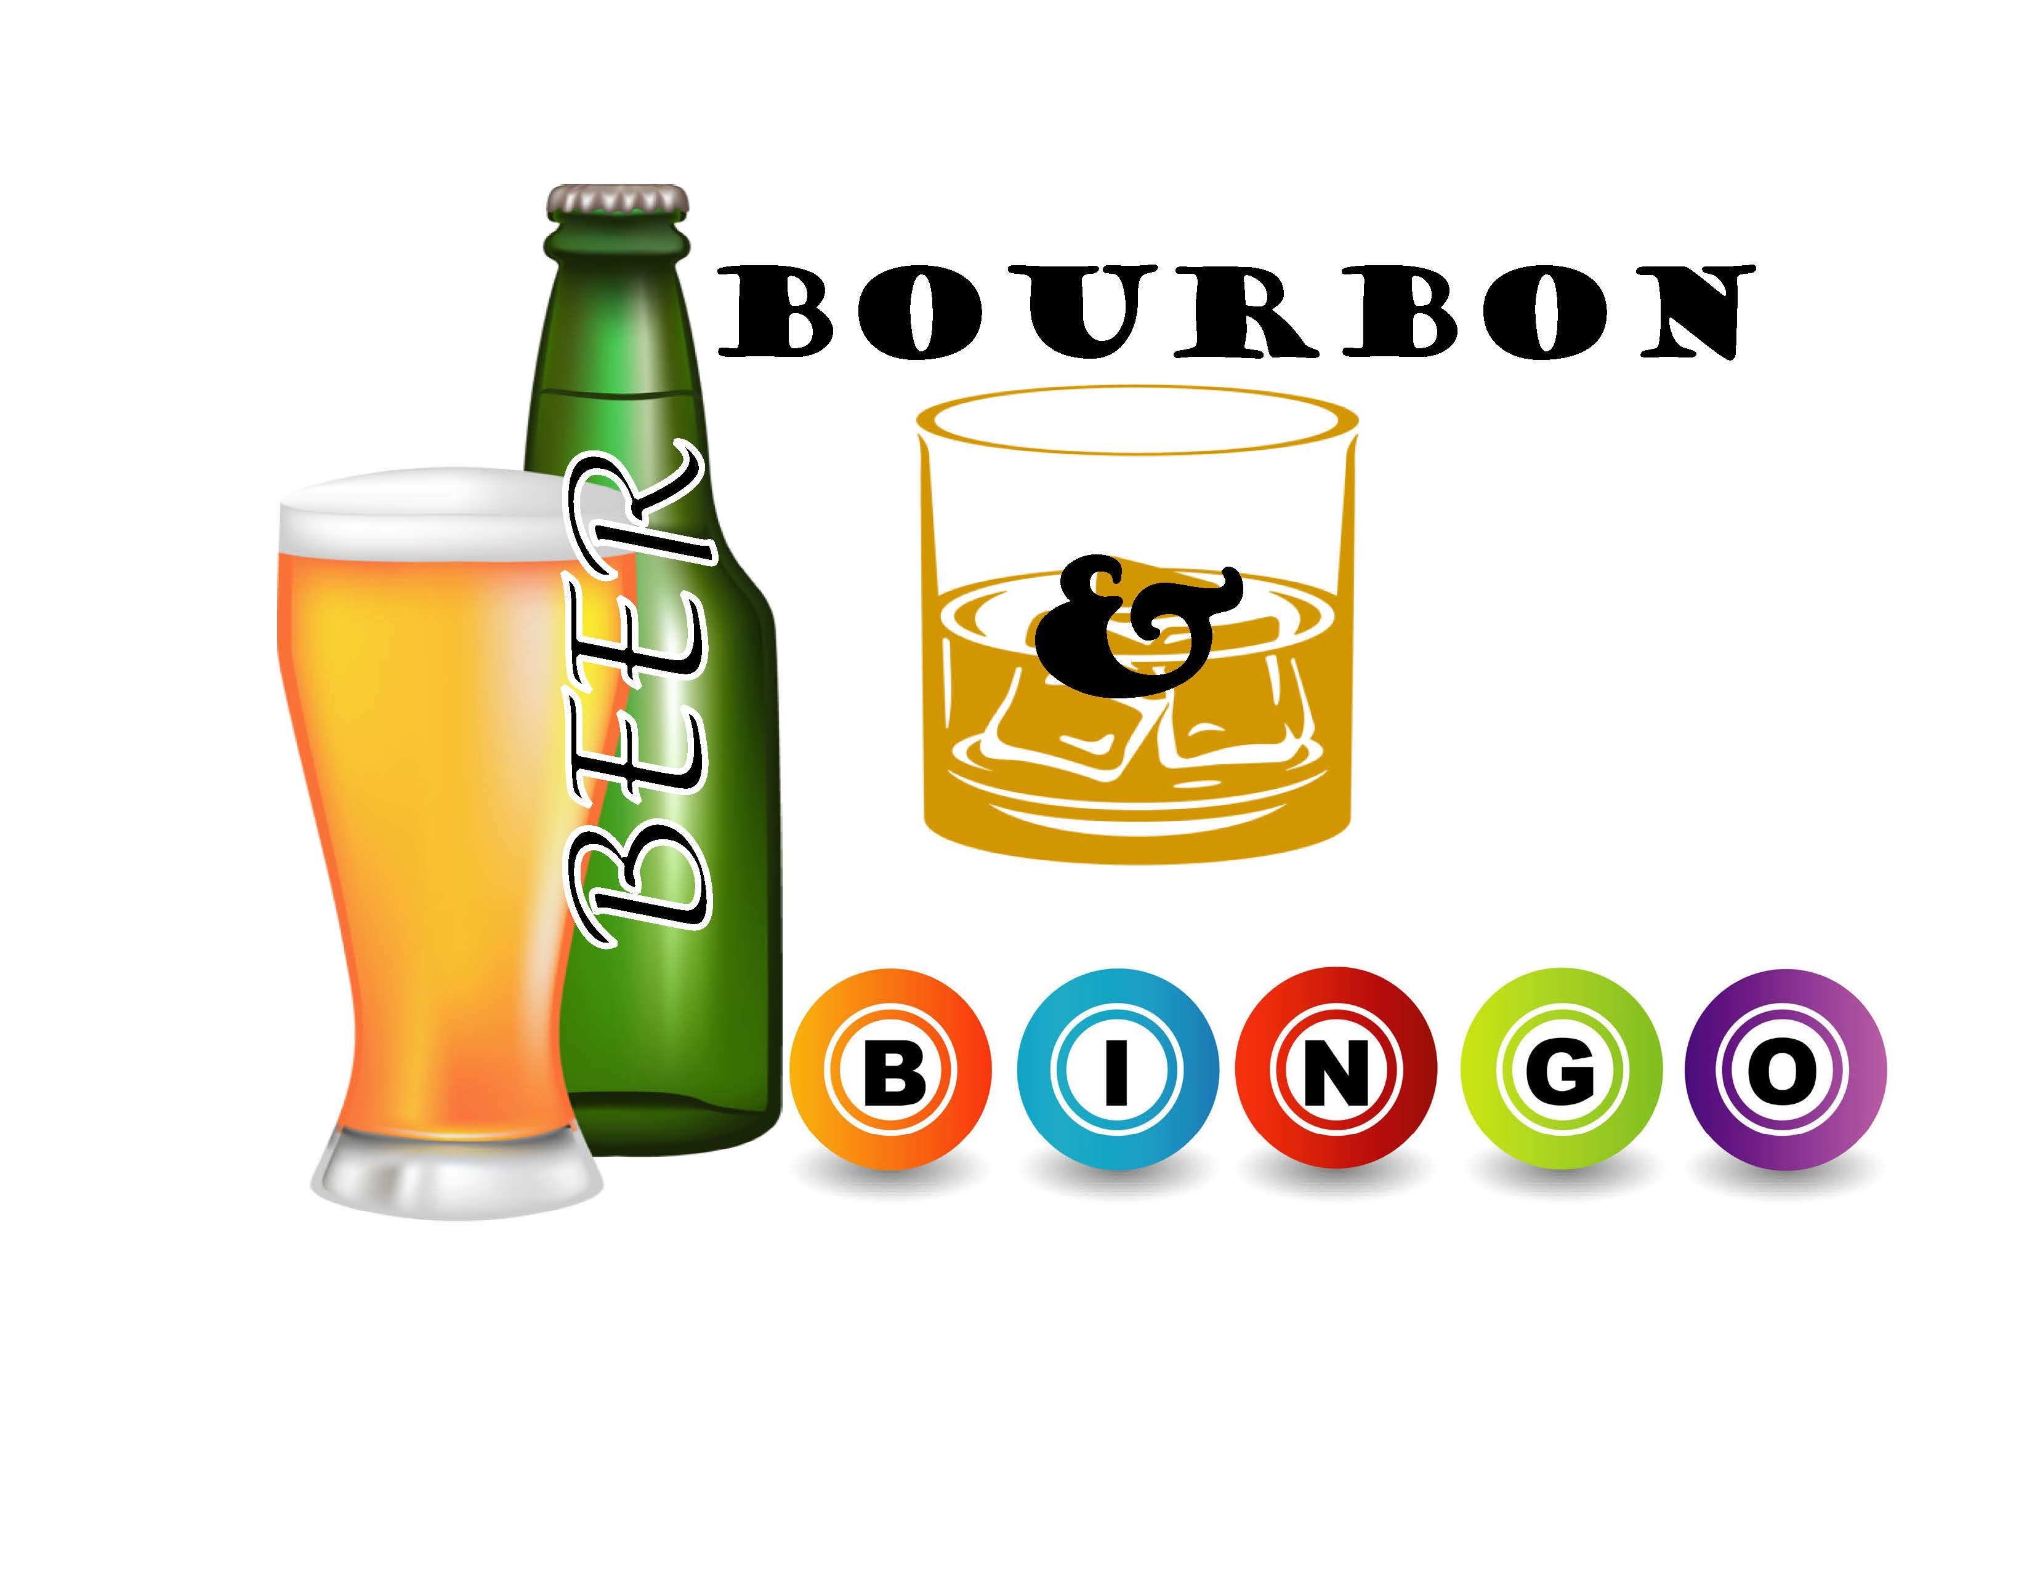

We are asking for sponsors to support Beer Bourbon & Bingo in one or more of the following ways! All proceeds from the event will support the programs and services of The Neighborhood Center. We hope we can count on your support.
Sponsor Name:
Contact Name:
Address:
Email: Phone:
CHECK THE WAYS YOU WILL SUPPORT
Donate $150 to sponsor a Designer Purse or Themed Gift Basket
(receive 1 event ticket, 1/2 page ad and recognition at the event prior to the game for the donated item)

Donate a designer purse or Themed Gift Basket valued at $200 or higher
(receive 1 event ticket, 1/2 page ad and recognition at the event prior to the game for the donated item)

Donate $50-$100 to sponsor a Gift Basket
(1/4 page ad in ad book)

Donate a Themed Gift Basket or Gift Card(s) valued at $50-$100
(1/4 page ad in adbook)

Donate items to be put in a Gift Basket
(name in ad book)

Event Tickets: ____@$25
Reserved Table (8 people): @$200
50/50 Raffle Tickets: @$2 each

TOTAL PAYMENT ENCLOSED:

We would like to pick up all purse, gift basket and gift card donations as soon as possible, unless you have perishable food items to donate. Email Debbie Albanese at d.albanese@cbheritage.com to arrange pickup or return this form (with donation) to Deb Albanese c/o The Neighborhood Center, 902 Philadelphia Road, Easton, PA 18042.

