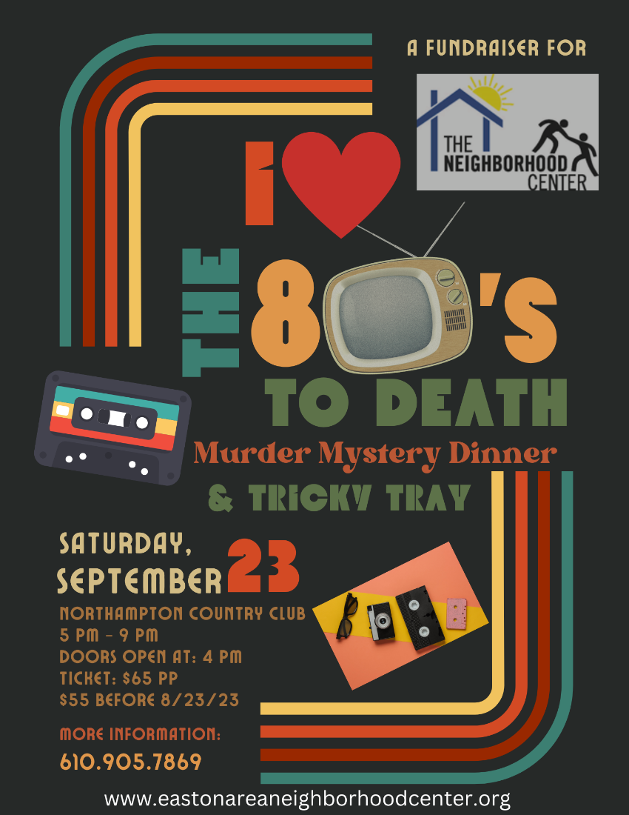

We are seeking donations for our A Night of Mystery Murder Mystery Dinner & Tricky Tray fundraiser. You can donate in one or more of the following ways. We hope we can count on your support.
Sponsor Name:
Contact Name:
Address:
Email: Phone:
Cash Donation

Gift Basket Donation

Gift Certificate/Gift Card Donation

Donate items to be put in a Gift Basket

Contact Debbie Albanese at d.albanese@cbheritage.com or 610-905-7869 to arrange pickup or return this form (with donation) to Debbie Albanese c/o The Neighborhood Center, 902 Philadelphia Road, Easton, PA 18042.

