November 1, 2019
Green Pond Country Club
3604 Farmersville Road, Bethlehem, PA

Doors open at 5 PM
Bingo beings at 7 PM
Admission includes 20 Games (3 cards per game)

50/50 Raffle ● Basket Raffles ● Special Games ● Beer Tasting ● Bourbon Flights

Support The Neighborhood Center
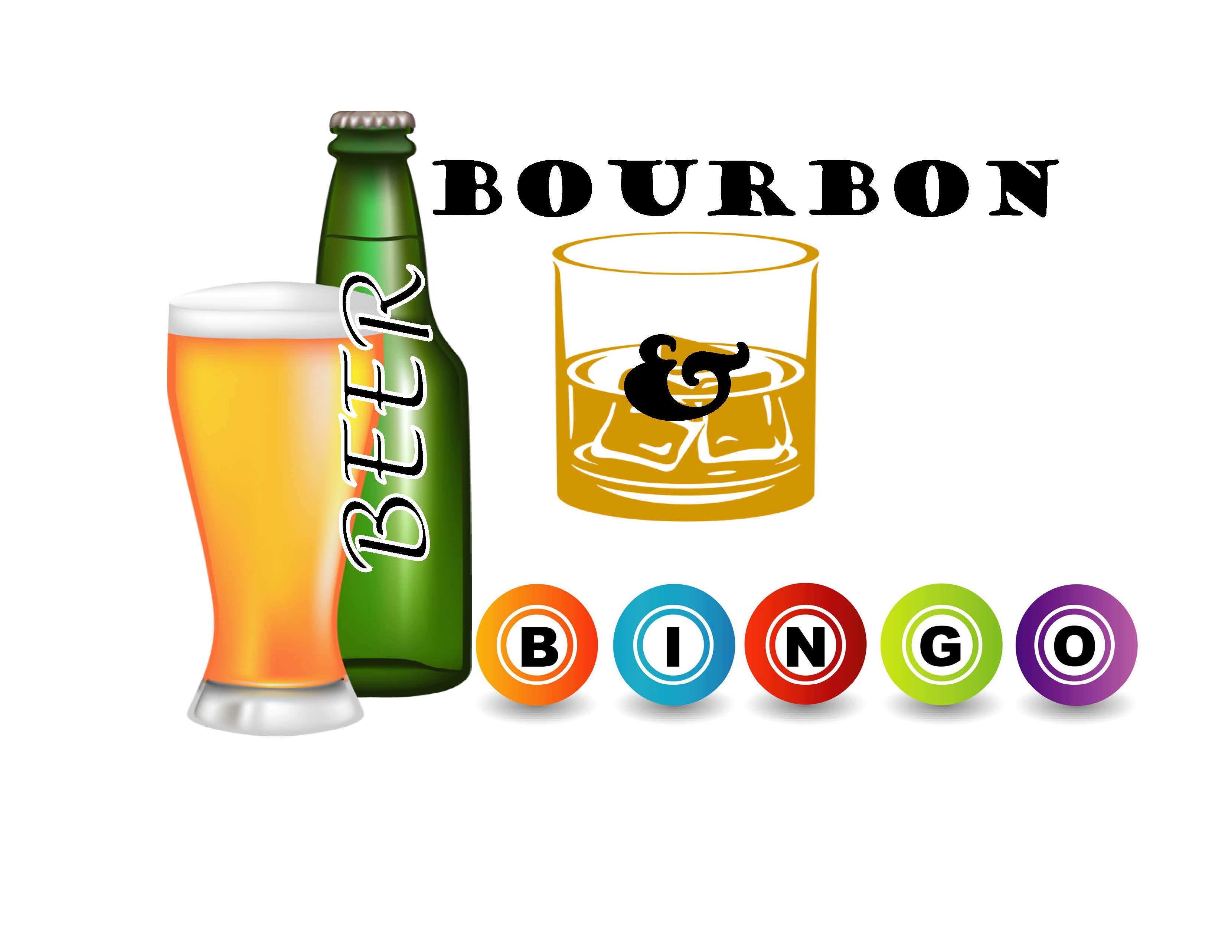

Barrel Sponsor--$5,000
Exclusive presenting sponsor, Name/Logo and link on event website, Full-page color ad on back cover of event program, Reserved table for 8, Grand Prize Coverall Game Sponsor, Name/Logo on Event promo items and t-shirts

Keg Sponsor --$3,000
Name/logo and link on event website, Full-page color ad in event program, Reserved table for 8, Wheel of Bourbon Game Sponsor, Name/Logo on Event promo items and t-shirts

Growler Sponsor--$1,000
2 Event tickets, Food Station Sponsor, Name/Logo on Event t-shirts, Half-page ad in program

Yard Sponsor--$500  - Name on event signage  - Full-page ad in program book  - 4 complimentary tickets  - Regular Bingo Game Sponsorship | Stein Sponsor--$300  - Half-page ad in program book  - Regular Bingo Game Sponsorship  - 2 complimentary tickets | Pint Sponsor--$100  - Quarter-page ad in program book  - 1 complimentary ticket
Program Book Advertisement  Full-Page: $150 ($200 Color)  Half-Page: $100 ($150 color)  Quarter-Page: $75 ($125 color) | Event Tickets  $25 each  $200 Reserved table for 8 | 50/50 Raffle Tickets ($500 min. prize)  $2 per ticket

Name: Phone: Email:
Address:
Person/business/organization to be listed & announced for sponsorship:
Ad: full page (8”x5”) 1/2 page (4”x5”) 1/4 page (2” x 5”) Color B&W
will send ad copy via email to ilong@eastonanc.org create ad for me
Sponsor level: Barrel Keg Growler Yard Stein Pint
Tickets (specify quantity being purchased) 50/50 Tickets (specify quantity being purchased)
Total amount enclosed $

