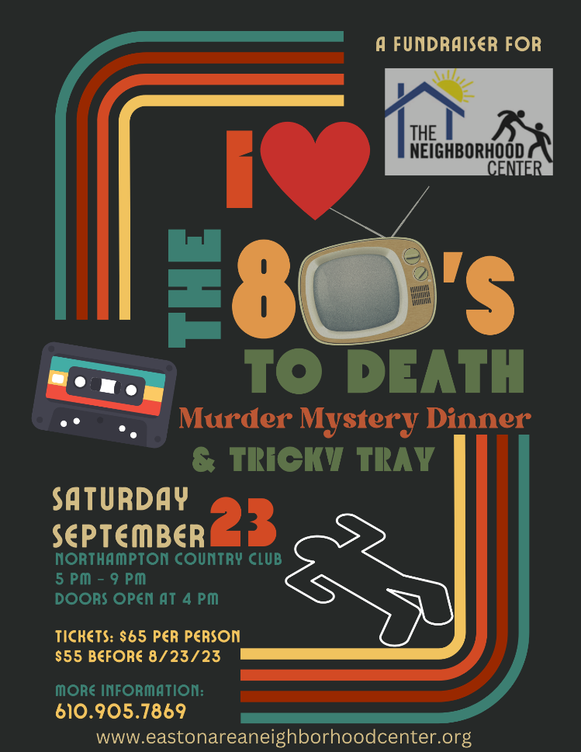
I LOVE THE 80’s TO DEATH
MURDER MYSTERY & TRICKY TRAY
ORDER FORM

Name:

Phone:

Email:

Mailing Address:

Person/business/organization
to be listed for sponsorship:

Sponsor
 | Presenting Sponsor | $2,500
 | Platinum Sponsor | $1,000
 | Gold Sponsor | $1,000
 | Silver Sponsor | $500
 | Bronze Sponsor | $250
Program Book Advertisement
 | Full-page (color) | $200
 | Full-page (b&w) | $150
 | Half-page (color) | $150
 | Half-page (b&w) | $100
 | Quarter-page (color) | $100
 | Quarter-page (b&w) | $50
Event Tickets
 | Early Bird Ticket (before Aug 23) | $55
 | Individual Ticket | $65
 | Reserved Table of 10 | $600
TOTAL AMOUNT ENCLOSED

Return this form with check payable to Easton Area Neighborhood Centers to: Isla Long, The Neighborhood Center, 902 Philadelphia Rd., Easton, PA 18042.

