SPONSORSHIP INFORMATION  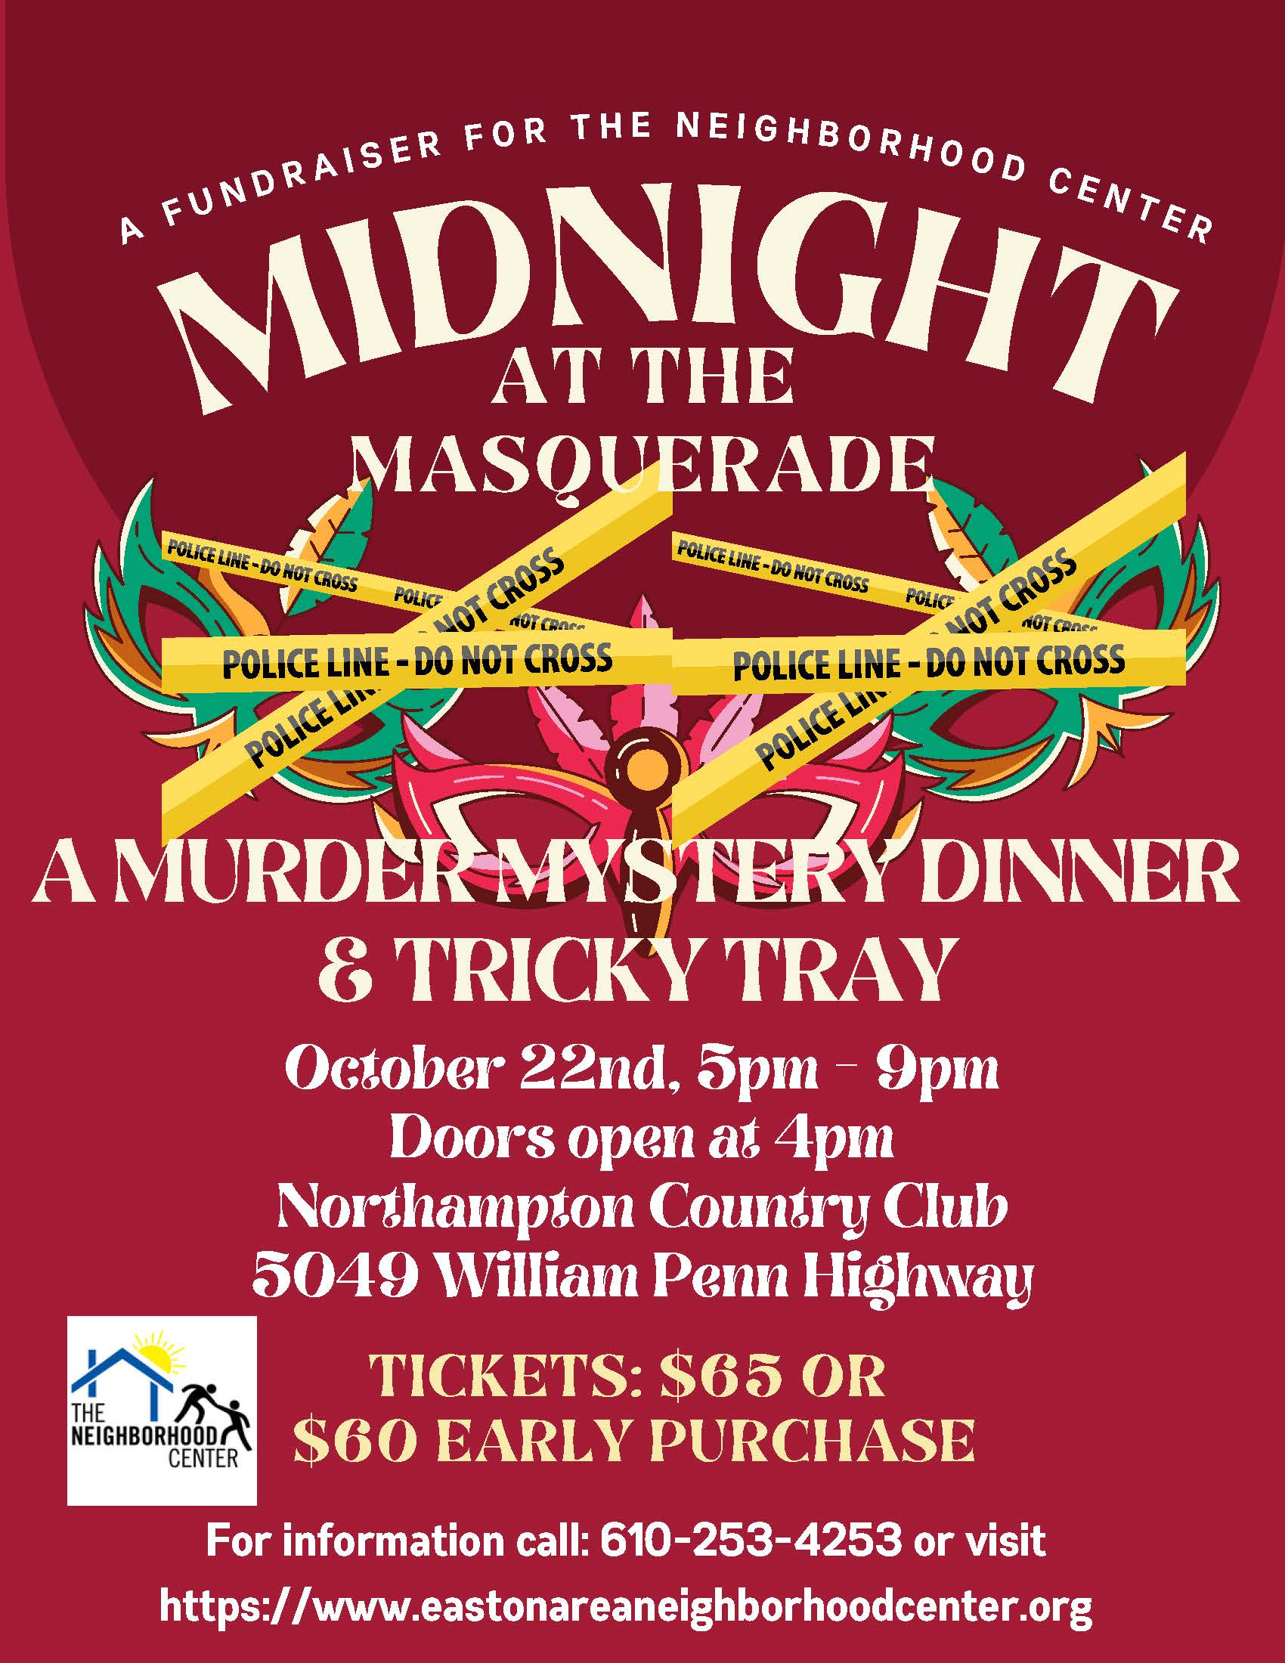 | Presenting Sponsor – $2,500 (1)
- Name/Logo and Link on Event Website
- Name in press materials and event signage
- Name/Logo on Cover of Event Program
- Full-Page Color Ad on Back Cover of Event Program
- 10 complimentary event tickets
- Name/Logo on Volunteer T-shirts as “Presenting Sponsor”
 | Platinum Sponsor – $1,500
- Name/Logo and Link on Event Website
- Name in press materials and event signage
- Full-Page Color Ad in Event Program
- 8 complimentary event tickets
- Name/Logo on Volunteer T-shirts
 | Gold Sponsor – $1,000
- Name in press materials and event signage
- Full-Page Color Ad in program book
- 6 complimentary event tickets
- Name/Logo on Volunteer T-shirts
 | Silver Sponsor – $500
- Name on event signage
- Full page B&W ad in program book
- 4 complimentary event tickets
- Name/Logo on Volunteer T-shirts
 | Bronze Sponsor - $250
- half page ad in program book
- 2 event tickets
 | Program Book Advertisement
Full page: $200 color; $150 B&W
Half page: $150 color; $100 B&W
Quarter page: $100 color: $50 B&W
The Neighborhood Center
902 Philadelphia Road
Easton, PA 18042
(610) 253-4253
www.eastonareaneighborhoodcenter.org

